Important Spring 2021 DE Dates

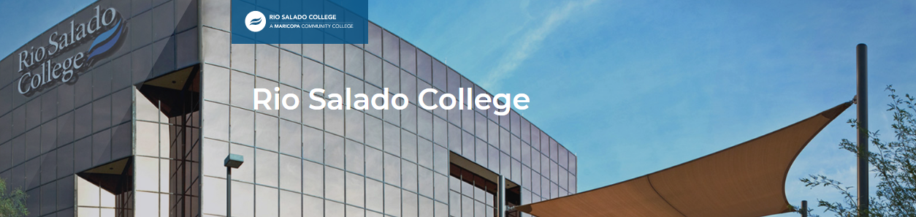

October – March 1st Register students for Spring 2021

January 4th Tuition due & purge begins and runs every Monday until February 16th

February 16th DE classes start
www.RIOSALADO.EDU/DUAL

Last day students can self-enroll

March 1st Deadline for students to pay for courses
Deadline to drop students for non-payment

March 15th -21st Spring Break

March 26th Last day to drop with a W

May 28th DE classes end

