_________________________________________________________________________________________

Using Brainbook

Instructions for helping students use Brainbook
Students: To register for a new account visit https://learn.barrowneuro.org and select “Create New Account”

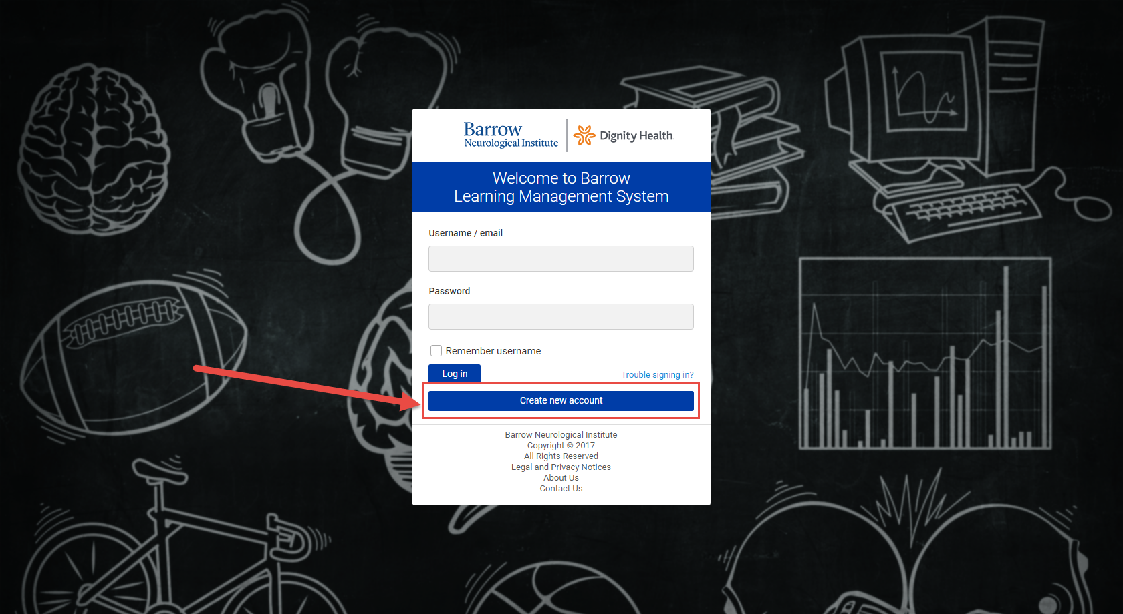

You will then be prompted to fill out your personal user information and accept the terms and conditions for use of Barrow Brainbook. Once completed, you will receive an email to confirm your account and return to https://learn.barrowneuro.org.

After you return to https://learn.barrowneuro.org, login in with your credentials. You will go to the default home screen of “My courses” where any courses you have enrolled in will be displayed. To enroll in Brainbook, navigate to “Available Courses” and click on “CAA Brainbook”.

See steps below:

Filling out Personal User Information:
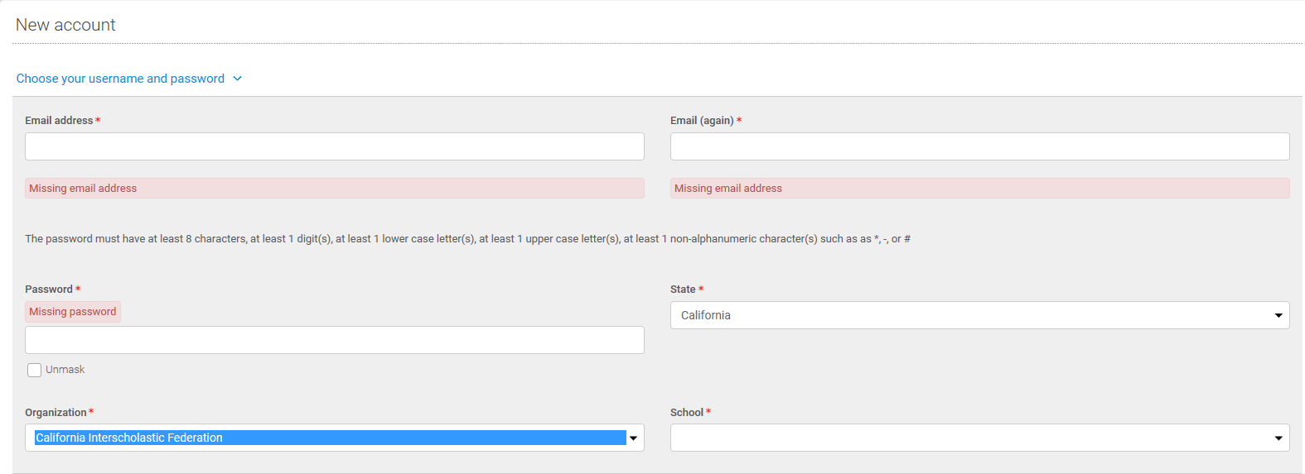

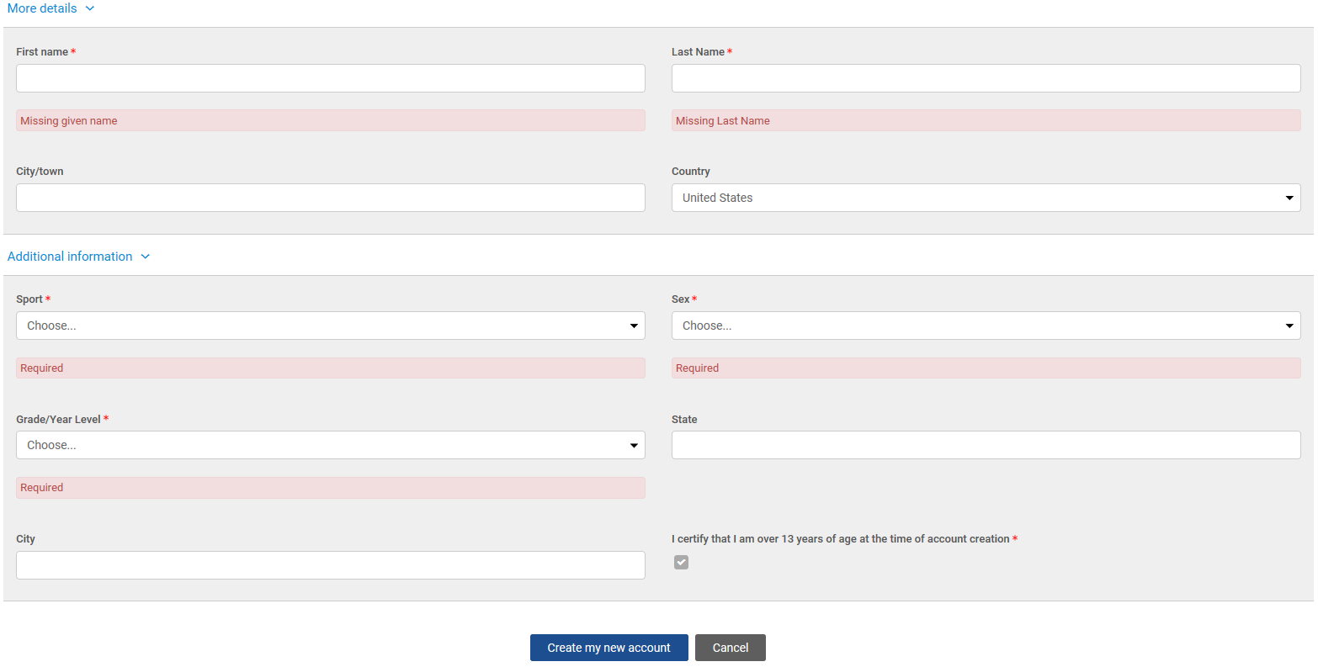
After all required fields are entered, select “create my new account” to access your Barrow Brainbook course.

Accessing Barrow Brainbook Education Course:

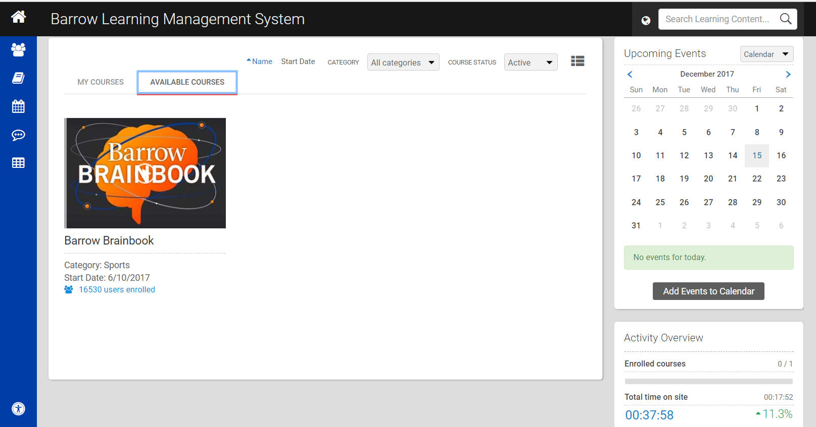
To access the Barrow Brainbook course, first select “available courses” then select “CAA Brainbook”.

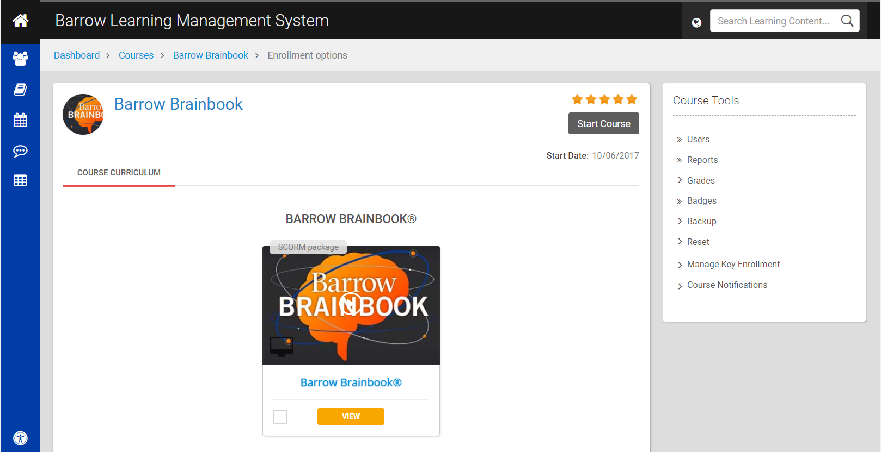
To begin the education, select “start course”.

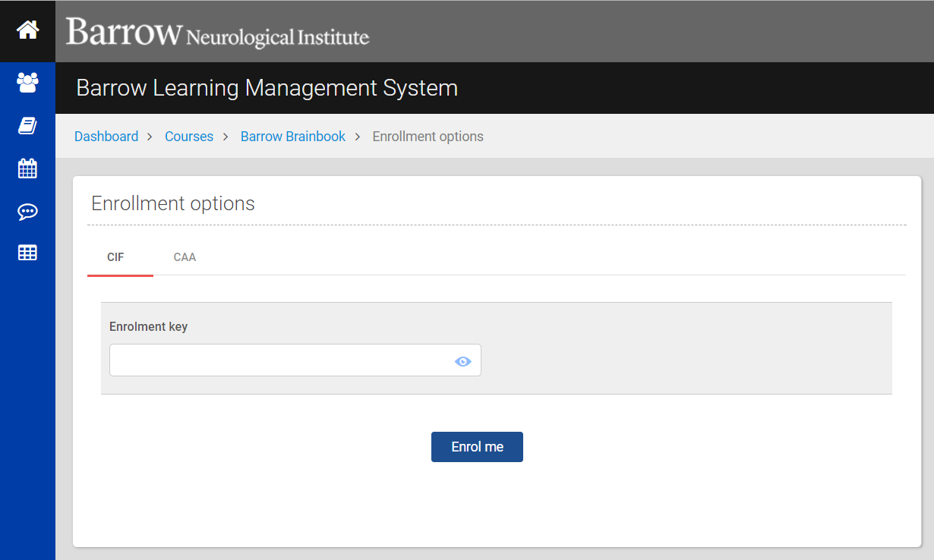
Enter the key and select “Enroll me” and you will be re-directed to start the course.

Be sure to select CAA where you will be prompted to enter your enrollment key: CAA18!

If you have any questions or technical difficulties you can always reach us at concussiondiscussion@barrowneuro.org

